**Chapter 1**

1. **INTRODUCTION**

Light Fidelity (Li-Fi) is a Visual Light Communication (VLC) based technology that uses light-emitting diodes (LEDs) to fully networked wireless system. It enables the electronic device to connect to the internet with no wire. To make a communication line between node, a Li-Fi will need a transceiver to transmit and receive the data. Li-Fi can be used for various applications but this paper focuses on the vehicle to vehicle communication. It is important to have a vehicular communication system as they are more widely adopted as vehicles are given increased autonomy in the world. The response time of autonomous systems are much faster than human, and this is a motivator behind increasing autonomy in vehicles as they can enhance safety. It is significant, and growing, research activity in vehicular communications. A key interest has been early stage autonomous systems that identify and responds to the impending threats (e.g. someone about to run a red light), and having this information exchanged in a wireless channel between the vehicles, with the vehicles issuing warning indicators to the human operators or alternatively proactively taking control of the vehicle and braking. The major challenge with existing technologies is its low data, transmission speed, high power consumption, and limited bandwidth. This technology uses LEDs for data transmission which ultimately increases the speed of data transmission and reduces the power consumption and use the wide range of bandwidth. Visible light eliminates protocol (electromagnetic), reducing the complexity of the system.

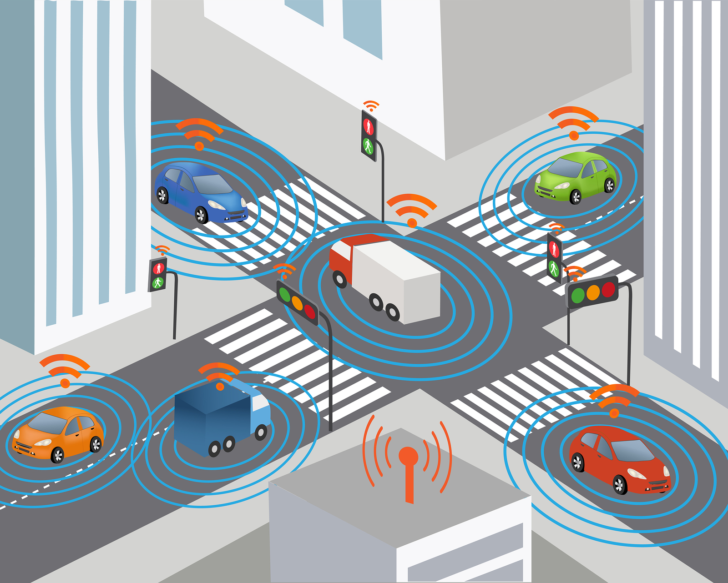

Fig 1.1: Vehicle to Vehicle Communication using Li-Fi

* 1. **Problem Statement**

The major challenge with existing technologies is its low data, transmission speed, high power consumption, and limited bandwidth. This technology uses LEDs for data transmission which ultimately increases the speed of data transmission and reduces the power consumption and uses a wide range of bandwidth. Visible light eliminates protocol (electromagnetic), reducing the complexity of the system.

* 1. **Limitations of the Current Work**

The proposed system will be able to properly function when there is no light. During the day intense sunlight may interfere in Li-Fi communication which can lead to the generation of error messages. Also, other light sources, such as normal light bulbs, may also interrupt the communication.

* 1. **Objectives**

1. To identify that Li-Fi technology is better in vehicle to vehicle communication than other technologies.
2. To explain how exactly the communication between the vehicles happen using Li-Fi technology.
3. To make recommendations and to improve the existing system by combining with the Li-Fi technology.

**Chapter 2**

1. **LITERATURE SURVEY**
2. **Title:** Li-Fi Based Automatic Traffic Signal Control for Emergency Vehicles.

**Author:** Shanmughasundaram R, Prasanna Vadanan S, Vivek Dharmarajan

**Implementation**

An emergency vehicle consists of a Li-Fi transmitter which is implemented using its headlight. When it enters a traffic congested lane, it broadcasts an alert message like “EMERGENCY VEHICLE”. If there is a non-emergency vehicle in front of it, the alert message will be received by the transceiver of the non-emergency vehicle. When the non- emergency vehicle receives the alert message, the driver of the vehicle will be informed using the vehicle infotainment system. At the same time, it will transmit the alert message either to a vehicle, if present in front or to the traffic signal control. The signal control, on receiving the alert message, will turn green. The alert message can be hopped across any number of vehicles till it reaches the traffic signal control. Therefore, however long the traffic jam is, the alert message will reach the traffic signal control in a short span of time.



Fig 2.1.1: Block Diagram of Li-Fi based Traffic control system

**Limitations**

1. The vehicle head and tail lights need to be kept ON even during the day for Li-Fi to work but the intensity can be maintained at a minimum level.
2. Li-Fi works efficiently when the transmitter and receiver are placed in Line of Sight. Any deviation from this position can lead to miscommunication.
3. During the day, intense sunlight may interfere in Li-Fi communication. Also, other light sources, such as normal light bulbs, may also interrupt the communication.
4. **Title:** Collision Avoidance between Vehicles through Li-Fi based Communication System.

**Author:** Abdul Aleem Jamali, Mahesh Kumar Rathi, Abdul Hakeem Memon, Bhagwan Das

**Implementation**

The proposed system comprises of a transmitter and a receiver section. The back lights of vehicle A is acting as transmitter and is sending the pulses of 0s and 1s. The flickering of LEDs should be done very fast so that it cannot be visualized by human eye. A photodiode which is placed at front of vehicle B is receiving the transmitted data in the form of current. The system is applicable to scenario when vehicle A is braking, rear lights transmits the alert of brake to vehicle B so that collision can be avoided. Block diagram of transmitter and receiver respectively.



Fig 2.2.1: Block diagram of Li-Fi communication system

**Limitations**

Reliable property and network coverage are serious problems to be considered because the interference from external light sources like sun light, bulbs and opaque materials in the path of transmission results in disturbance in the communication.

1. **Title:** Li-Fi technology in Traffic light.

**Author:** V. K. G. Kalaiselvi, A. Sangavi, Dhivya

**Proposed System**

Traffic lights also can communicate to the car and communication can be established even between two cars as cars have front and back LED lights and thereby preventing or at least decreasing accidents. The proposed system aims in communicating the siren lights of an ambulance with the traffic control system i.e., when an ambulance reaches near the traffic control the LED bulb of the siren and the LED bulb of the traffic control system communicates and the red light of the traffic control system turns into green signal thereby providing way to the ambulance to move on rather than by a manual method. This proposed system will help in saving time and thereby saving life of a person in ambulance in heavy traffic.

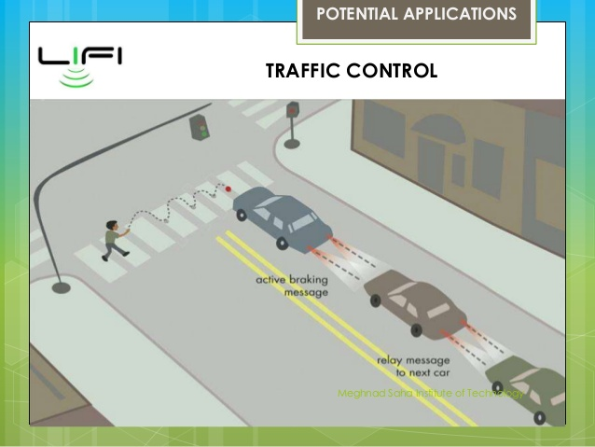

Fig 2.3.1: Vehicle to Vehicle Communication using Visible Light

1. **Title:** Smart navigation with AI Engine for Li-Fi based Medical Indoor Environment.

**Author:** Ho Kyung Yu, Jeong Gon Kim

**Proposed System for Smart Navigation**

To implement the system proposed in this paper, firstly, the location information of the user is collected. The user's LC device sends the beacon signal to the LED (AP) and transmits the current position of the patient. AP transmits location information of users to the Central Server. Central Server uses patient location information to create patient location information map. In the patient location information map, the user is divided into Using Patient, Waiting Patient, and Visitor. Patients who entered the patient's symptom using the LC Device are classified as using Patient and Waiting Patient, and others are classified as Visitor. Using Patient is a patient who is currently using a clinic. Waiting Patient is a patient waiting to use Clinic. The visitor is a patient who has not yet received it or a visitor who has visited the hospital.



Fig 5: Conceptual diagram for transmitting and receiving location information

**Chapter 3**

1. **DESIGN METHODOLOGY**

**3.1 Hardware Description**

**Amplitude-Shift Keying (ASK) Modulator**

It is the digital modulation technique in which low frequency modulating signal is superimposed on high-frequency carrier signal for long distance transmission. For ASK signal generation IC 4015B is being used in the project. It is a multiplexer IC. The pin diagram is shown below:-

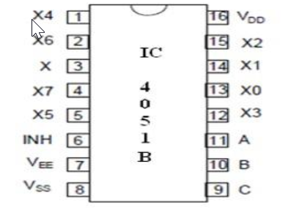

Fig 6: Pin Configuration

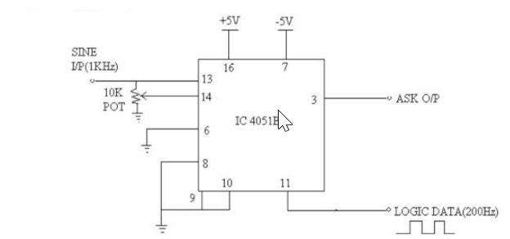

Fig 7: ASK Modulator

The hardware setup is shown in the figure above. The sine wave (carrier signal) is applied at pin no. 14. The modulating signal is given at pin no. 11. The modulating signal is of 200Hz. The carrier frequency is set to 2KHz. The potentiometer that has been used is of 47KOhms. The ASK output is observed at pin no. 3. The output of the modulator is amplified so that the voltage produced is suitable to drive the LEDs. The amplifier in the modulator section is a noninverting amplifier. IC 4051B is used for multiplexing as a carrier and a modulating signal is sent together. ASK generation is possible by using IC 555. But ASK generation using IC 555 needs two ICs. Whereas by using only one IC 4051B we can generate ASK signal.

* + 1. **Voltage Amplifier**

At the output of the ASK Modulator section, the value of voltage which is required to drive LEDs is very low. So, to drive LEDs, we required to amplify the voltage. Voltage amplifier is designed using OP-AMP IC 741 in the non-inverting configuration.

* + 1. **LED’s**

This system would require some special LEDs as the transmission is done in meters and kilometers. The normal LEDs that are used in the lab circuits have a very less luminous intensity. The luminous intensity is a measure of how bright the LED can get. The standard unit for measuring light intensity in candela (cd).

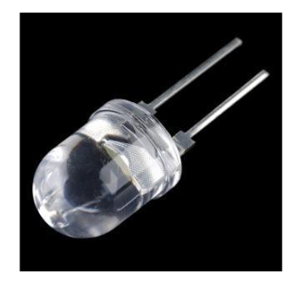

Fig 8: White LED

So, the LED that is being used in this system is the Super bright white LED. This LED provides an intensity of 16,000-20,000 millicandela (mcd). It has a 30-degree viewing angle.

* + 1. **LED’s**

With respect to the LED that is used the photodiode selected is SFH 231. The semiconductor material used is germanium. This photodiode is suitable for applications from 600nm to 1800nm. It has short switching time typically 9ns.

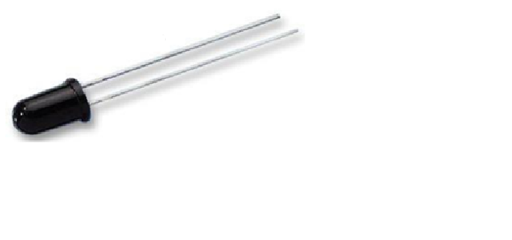

Fig 9: SFH 231

* + 1. **Envelope Detector and Filter**

An envelope detector is an electronic circuit that takes a high-frequency signal as input and provides an output which is the envelope of the original signal. This system is using this circuit in the demodulator section.

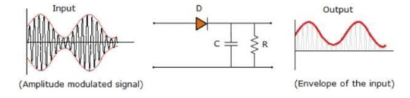

Fig 10: Envelope Detector Circuit

The ASK modulated output is applied to the detector circuit. The input signal is rectified by the diode D in the detector circuit. The combination of the capacitor C and resistor R acts as low-pass filter. The capacitor helps in filtering out the RF carrier waves present in the input signal i.e. the ASK modulated output. Thus, the capacitor helps in giving an envelope of input as output.

**Chapter 5**

1. **PROPOSED SYSTEM**

This paper proposes a Li-Fi based system to transfer data from one device to another using visible light. The proposed system consists of Li-Fi transmitter and receiver circuits with LEDs, photo-detector, MAX232A IC and inverter, battery, connecting wires and USB or COMM port. The sending device will select some data to the transmitter circuit of the sender’s device. The LEDs in the transmitter circuit will transmit this data. The photo-detector of the receiver circuit will receive this data from the light detected and will send it to the receiving device which will interpret and obtain the final data that was sent by the sender.

The proposed Li-Fi system will consist of the following modules:

1. Graphical user interface
2. Data reading module
3. Data conversion module
4. Transmitter module
5. Receiver module
6. Data interpreter module

The different modules and the flow of data between these modules are shown in Fig 8. The Data reading module reads data from the sender device and sends this data to the data conversion module.

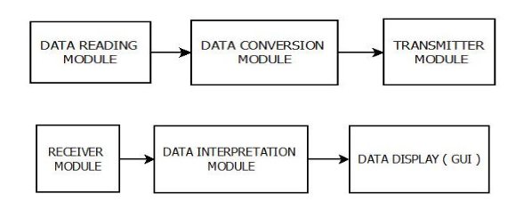

Fig 8: Block Diagram of Li-Fi System

The data conversion module converts this data into suitable format, i.e. in the form of binary bits (byte format) so that it can be represented as a digital signal. Before converting this data into binary form, the data conversion module can also apply some encryption algorithm to encrypt the sender’s data. The data is then sent to the transmitter module which generates the corresponding on-off pattern of the LEDs. In this way, data is sent from the sender. The Receiver module receives the data. The receiver module has a photo-diode to detect the on and off states of the LEDs. The receiver module captures this sequence and generates the binary sequence of the received signal. It then sends the binary sequence to the Data interpretation module which converts the data to the original format. If encryption was done at the sender, then Data interpretation module also performs decryption. It then sends the final result to the Data display module which displays the final received data to the receiver. In this way, the data is received by the receiver in a Li-Fi system.

* 1. **Flow Diagram**

In Li-Fi system, which is based on visible light communication, data is modulated on the light source using modulation techniques like pulse position modulation or frequency shift keying. In the receiver end demodulation is performed using pulse position modulation technique to fetch the data back from the light source.

So, it forms a six-step process (shown in Fig. 5):

1. Read data from Sender
2. Modulation
3. Transmit data using Light Source (LED)
4. CMOS/CCD
5. Demodulation
6. Received Data

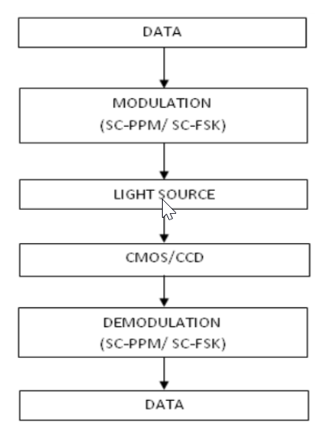

Fig 9: Flow Diagram of Li-Fi

Operational procedure is very simple. If the LED is on, you transmit a digital 1. If it is off, you transmit a 0. The LEDs can be switched on and off very quickly, which gives nice opportunities for transmitting data. Hence all that is required is some LEDS and a controller that code data into those LEDs.

* 1. **Comparison Between Li-Fi and, Wi-Fi and other Radio Communication technologies ?**

LI-FI is a term of one used to describe visible light communication technology applied to high speed wireless communication. It acquired this name due to the similarity to WI-FI, only using light instead of radio. Both Wi-Fi and Li-Fi can provide wireless Internet access to users, and both the technologies transmit data over electromagnetic spectrum. Li-Fi is a visible light communication technology useful to obtain high speed wireless communication. The difference is: Wi-Fi technology uses radio waves for transmission, whereas Li-Fi utilizes light waves. Wi-Fi works well for general wireless coverage within building/campus/compound, and Li-Fi is ideal for high density wireless data coverage within a confined space or area and is free from interference problems in contrast to the Wi-Fi.

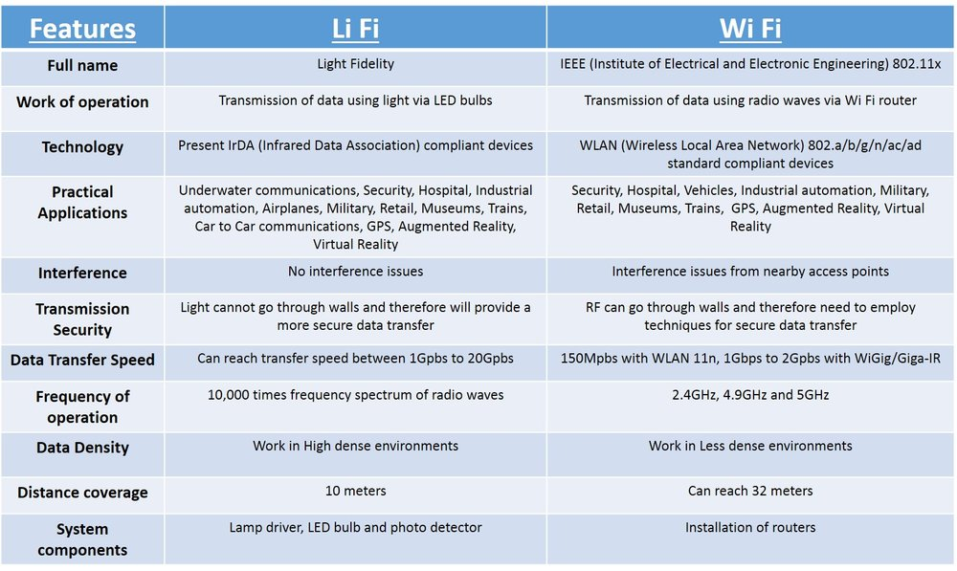

Fig 9: Comparison between Li-Fi and Wi-Fi

* 1. **How it is different?**

Li-Fi innovation depends on LEDs for the exchange of information. The exchange of the information can be with the assistance of a wide range of light, regardless of the piece of the range that they have a place. That is, the light can have a place with the imperceptible, bright or the noticeable piece of the range. Additionally, the speed of the web is amazingly high, and you can download motion pictures, amusements, music and so on in only a couple of minutes with the assistance of this innovation. Additionally, the innovation expels constraints that have been put on the client by the Wi-Fi. You no more should be in a district that is Wi-Fi empowered to approach the web. You can basically remain under any type of light and surf the web as the association is put forth in defense of any light nearness. There can't be anything superior to this innovation.

* 1. **Weaknesses of Radio Waves Transmission opposite Li-Fi Transmission**

Here are some limitations of radio waves over Light Fidelity

1. **Capacity:** Wireless information is transmitted through radio waves which are constrained and costly. It has a constrained transmission capacity, versus Li-Fi. With the quickly developing world what's more, advancement of advances like 3G, 4G, etc. we are coming up short on radio range.
2. **Energy Efficiency:** There are countless radio base stations that expend gigantic measure of vitality. Most of the vitality is utilized for chilling off the base station rather than transmission. In this manner, proficiency of such Radio base stations is low.
3. **Availability:** Availability of radio waves is a major concern. Further, Radio waves are most certainly not prudent to be utilized in planes and at spots where radio obstruction may cause unfortunate outcome.
4. **Security:** Radio waves can enter through dividers. They can be captured. On the off chance that somebody has learning and awful expectations, they may abuse it. This causes a noteworthy security worry for Wi-Fi.
   1. **Advantages of Li-Fi**

Li-Fi, that uses light to transmit signals wirelessly, is a rising technology poised to compete with Wi-Fi. Also, Li-Fi removes the restrictions that are placed on the user by the Radio wave transmission such as Wi-Fi as explained above vide 4.1. Advantages of Li-Fi technology include:

1. **Efficiency:** Energy consumption is minimized with the utilization of light-emitting diode illumination which are already available in the home, offices and Mall etc. for lighting purpose. Hence the transmission of knowledge requiring negligible further power, which makes it very efficient in terms of costs as well as energy.
2. **High speed:** Combination of low interference, high bandwidths and high-intensity output, help Li-Fi provide high data rates i.e. 1 Gbps or even beyond.
3. **convenience:** Availability isn't a problem as light-weight sources area unit gift everyplace. Wherever there's a lightweight supply, there can be Internet. Light bulbs are present everywhere – in homes, offices, shops, malls and even planes, which can be used as a medium for the data transmission.
4. **Cheaper:** Li-Fi not only requires fewer components for its working, but also uses only a negligible additional power for the data transmission.
5. **Security:** One main advantage of Li-Fi is security. Since light cannot pass through opaque structures, Li-Fi web is offered solely to the users at intervals a confined space and can't be intercepted and exploited, outside the area under operation.

Li-Fi technology features a nice scope in future. The extensive growth in the use of LEDs for illumination indeed provides the opportunity to integrate the technology into a plethora of environments and applications.

* 1. **Limitations of Li-Fi**

Some of the major limitations of Li-Fi are:

1. Internet cannot be accessed without a light source. This could limit the locations and situations in which Li-Fi could be used.
2. It needs a close to or good line-of-sight to transmit information.
3. Opaque obstacles on pathways can affect data transmission.
4. Natural light-weight, sunlight, and traditional electric lamp will influence the information transmission speed
5. Light waves don’t penetrate through walls and so Li-Fi has a much shorter range than Wi-Fi
6. High initial installation value, if wont to came upon a full-fledged information network.
7. Yet to be developed for mass scale adoption.
   1. **Applications of Li-Fi**

Some of the future applications of Li-Fi could be as follows

1. **Education systems:** Li-Fi is the latest technology that can provide fastest speed for Internet access. So, it will augment/replace Wi-Fi at academic establishments and at companies so the folks there will build use of Li-Fi with the high speed.
2. **Medical Applications:** Operation theatres (OTs) don't permit Wi-Fi thanks to radiation concerns. Usage of Wi-Fi at hospitals interferes/blocks the signals for monitoring equipment’s. So, it may have hazardous effect to the patient's health, due to improper working of medical apparatus. To overcome this and to make OT tech savvy Li-Fi can be used to access internet and to control medical equipment. This will be beneficial for conducting robotic surgeries and other automated procedures.
3. **Cheaper Internet in Aircrafts:** The passengers travelling in aircrafts get access to low speed web that too at a high worth. Also, Wi-Fi isn't used because of it should interfere with the navigational systems of the pilots. In aircrafts Li-Fi can be used for data transmission. Li-Fi can easily provide high speed Internet via every light source such as overhead reading bulb, etc. present inside the airplane.
4. **Underwater applications:** Underwater ROVs (Remotely Operated Vehicles) operate from massive cables that provide their power and permit them to receive signals from them pilots above. But the tether used in ROVs is not long enough to allow them to explore larger areas. If their wires were replaced with light-weight — say from a submerged, high-powered lamp — then they'd be abundant freer to explore. They could also use their headlamps to speak with one another, processing data autonomously and sending their findings periodically back to the surface. Li-Fi can even work underwater where Wi-Fi fails fully, thereby throwing open endless opportunities for military underwater operations.
5. **Disaster management:** Li-Fi can be used as a powerful means of communication in times of disaster such as earthquake or hurricanes. The average people may not know the protocols during such disasters. Subway stations and tunnels, common dead zones for most emergency communications, pose no obstruction for Li-Fi.
6. **Applications in sensitive areas:** Power plants need fast, inter-connected data systems so that demand, grid integrity and core temperature (in case of nuclear power plants) can be monitored. The Radio communication interference is bad for such sensitive areas surrounding these power plants. Li-Fi can offer safe, abundant connectivity for all areas of these sensitive locations. Also, the pressure on a power plant‘s own reserves (power consumption for Radio communications deployments) will be reduced.
7. **Traffic management:** In traffic signals Li-Fi can be used to communicate with passing vehicles (through the junction rectifier lights of the cars etc.) which might facilitate in managing the traffic in a higher manner ensuing into sleek flow of traffic and reduction in accident numbers. Also, junction rectifier automobile lights will alert drivers once different vehicles are too close.
8. **Mobile Connectivity:** Mobiles, laptops, tablets, and other smart phones can easily connect with each other. The short-range network of Li-Fi will yield exceptionally high data rates and higher security.
   1. **Conclusion**

Although there’s still a long way to go to make this technology a commercial success, it promises a great potential in the field of wireless internet. A significant number of researchers 15 and companies are currently working on this concept, which promises to solve the problem of lack of radio spectrum, space and low internet connection speed. By deployment of this technology, we can migrate to greener, cleaner, safer communication networks. The very concept of Li-Fi promises to solve issues such as, shortage of radio-frequency bandwidth and eliminates the disadvantages of Radio communication technologies. Li-Fi is the upcoming and growing technology acting as catalyst for various other developing and new inventions/technologies. Therefore, there is certainty of development of future applications of the Li-Fi which can be extended to different platforms and various walks of human life.